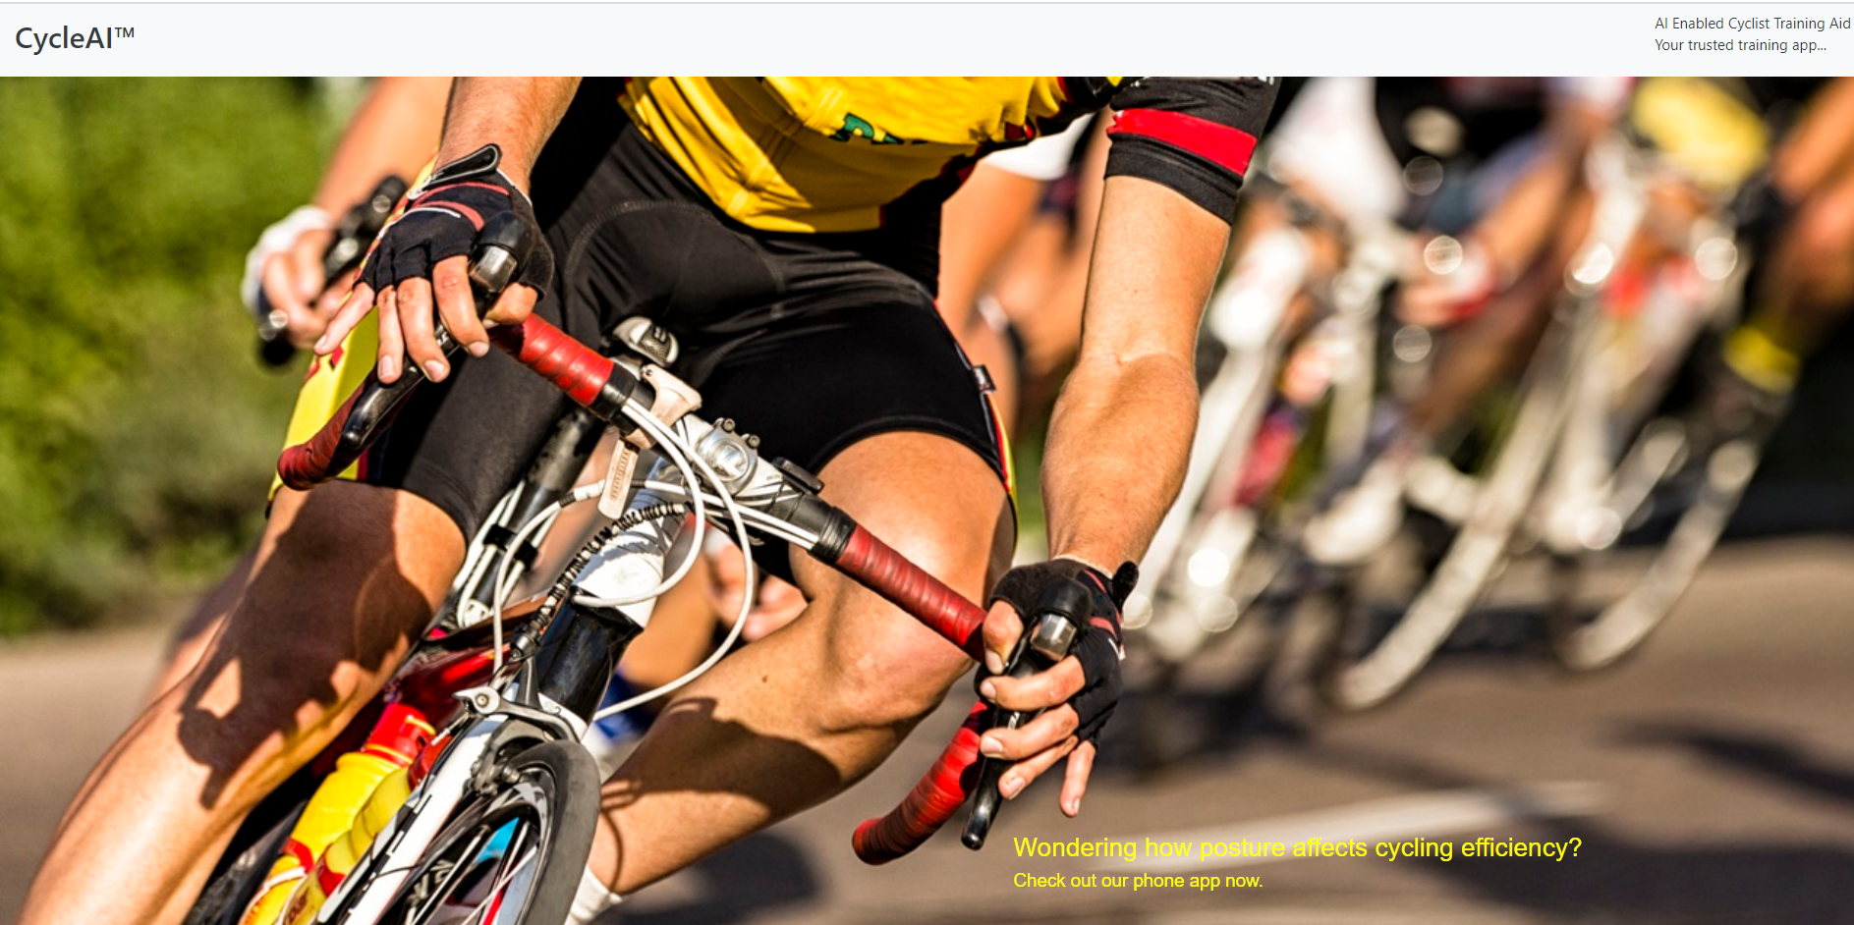

User Guide

Mahathir Bin Humaidi A0213486A

Pee Kian Soon A0213510B

Dong Xiaoguang A0066960X

**Local Deployment**

**Supported Browsers**

* Firefox 76
* IE 11
* Google Chrome 81

1. Open Anaconda prompt and create the virtual environment "proj"

*(base) C:\Users\username>conda create --name proj python=3.7*

1. Activate the proj virtual environment

*(base) C:\Users\username>conda activate proj*

1. Change the working directory to

*(proj) C:\Users\username>cd C:\Users\username\Desktop* ITTS\SystemCode

1. pip install requirements

*(proj) C:\Users\username>cd C:\Users\username\Desktop* ITTS\SystemCode *pip install -r requirements.txt*

1. *Run the app*

*(proj) C:\Users\username>cd C:\Users\username\Desktop* ITTS\SystemCode *> python app.py*

1. Access the app in browser

[*http://127.0.0.1:5000/*](http://127.0.0.1:5000/)

**Test Cases**

In this section, we will take a look at some test cases of our system.

Test Case #1

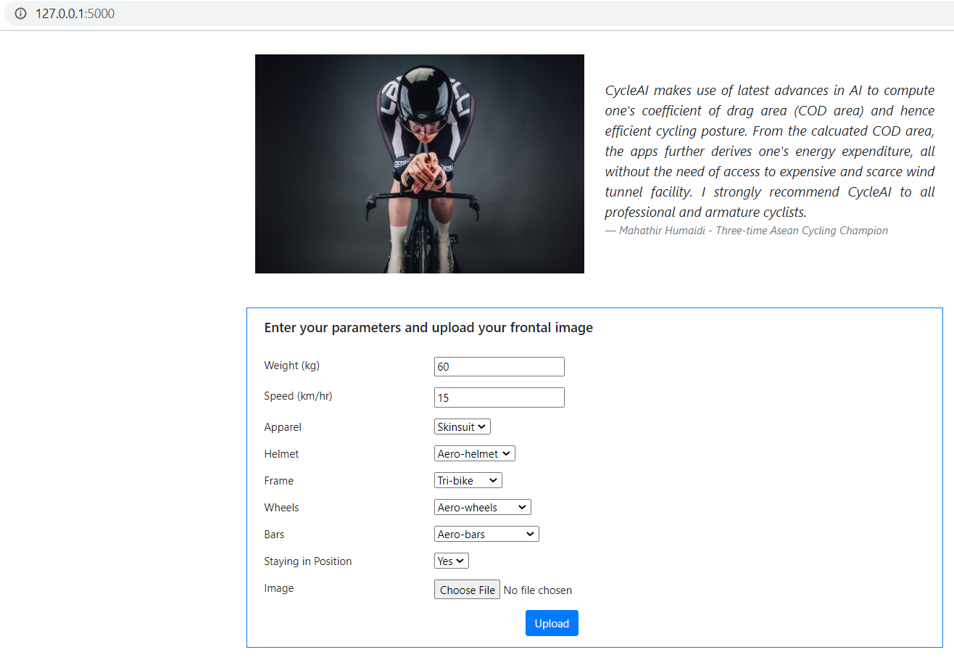

1. Key in the Weight and Speed. Choose the parameters (Apparel, Frame, Bars, etc.)

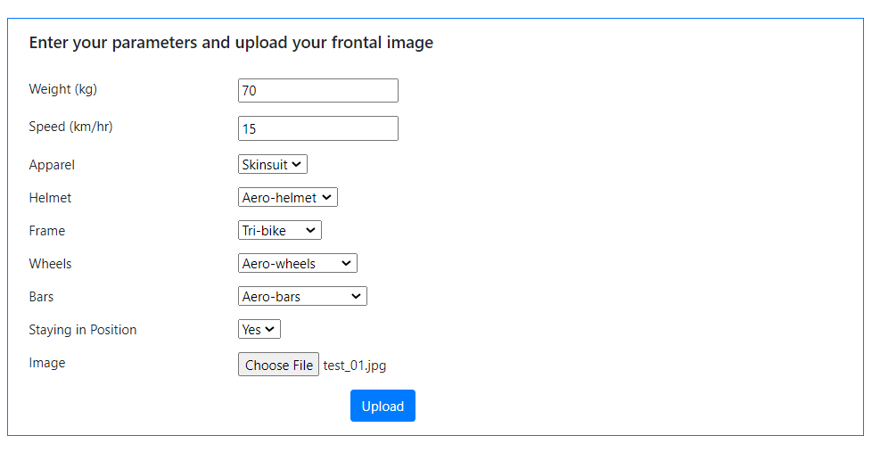

1. Choose an image of cyclist in riding posture ( test_01.jpg) and click "Upload".

*Sample images can be found under: \ITTS* *test image*

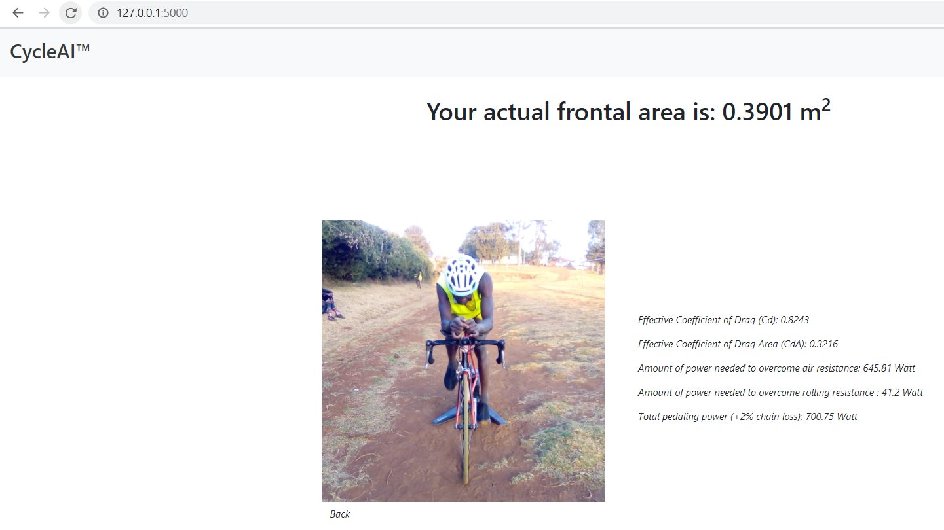

1. The app will output the actual frontal area based on the segmentation model’s prediction. It will also predict the effective coefficient of drag, effective coefficient of drag area and the corresponding paddling power under these parameter conditions.

Test Case #2

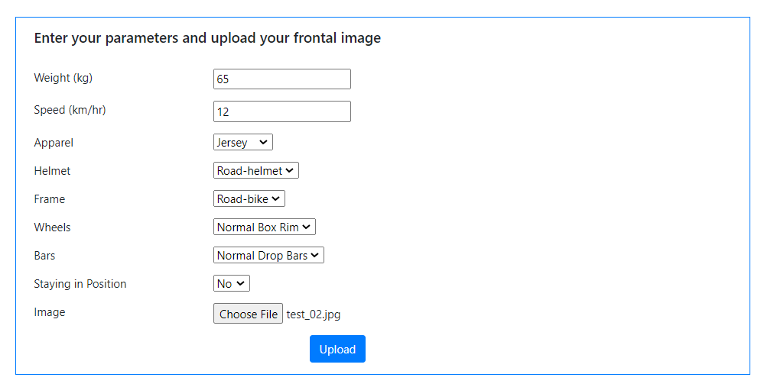

1. Key in the Weight and Speed. Choose the parameters (Apparel, Frame, Bars, etc.). Choose another image of cyclist in riding posture (test_02.jpg) and click "Upload".

*Sample images can be found under: \ITTS* *test image*

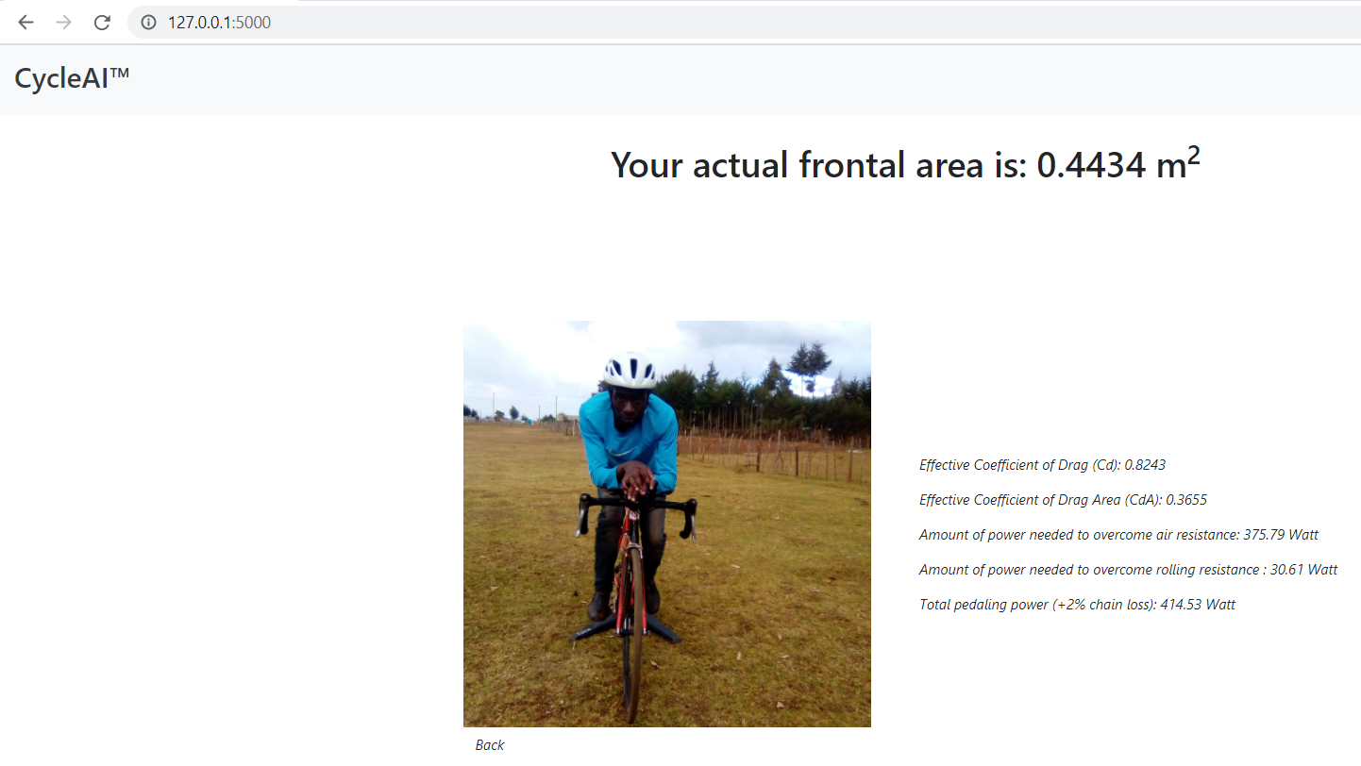

1. The app will output the actual frontal area based on the segmentation model’s prediction. It will also predict the effective coefficient of drag, effective coefficient of drag area and the corresponding paddling power under these parameter conditions.